Internships, MSc, and PhD on the Design of Reconfigurable Structures

POSITIONS SUMMARY
The Polystable research lab in the Department of Mechanical Engineering (http://www.polymtl.ca/meca/) seeks candidates for multiple projects in the design, simulation, and manufacturing of reconfigurable structures.
More specifically, the team is recruiting to fill multiple internship, master’s, and PhD positions on the following research projects:
Project 1 - Multi-stable Smart Composites (MuSCLE)
Goal: Design and manufacturing of flexible composite structures that can adapt their shape and mechanical properties based on external stimuli.
Tasks required: Literature review of smart composites for aerospace structures; Numerical simulations on the nonlinear mechanics of flexible and multi-stable structures; Additive manufacturing (FFF, DIW) of flexible structures with embedded actuation and sensing; Experimental characterization of mechanical properties; Life-cycle analysis.
Academic partners : McGill University, École de Technologie Supérieure, Le Mans Université.
Industrial partners: Safran Group, AON3D, Filspec inc., Eclore.
Project 2 – Design and additive manufacturing of meta-structures propelled by centrifugal force
Goal: Design a meta-structure with reversible elastic properties which can change its position with centrifugal force and exhibit stable states at different rpm levels.
Tasks required: Literature review on mechanical metamaterials and meta-structures; Numerical simulations of the nonlinear mechanics of multi-stable mechanical metamaterials; Additive manufacturing (LPBF) of metallic mechanical metamaterials; Experimental characterization of mechanical properties.
Partners: National Research Council of Canada (NRC).

Project 3 – Fabrication of flexible and inflatable actuators via the control of shell instabilities
Goal: Exploit mechanical instabilities triggered when subjecting thin shell to sudden loading to fabricate soft robotic actuators with programmable nonlinear response.
Tasks: Literature review of instability-driven fabrication of soft structures; Development of an instability-driven fabrication method for flexible actuators; Numerical prediction of the post-buckling shape of the actuators; Experimental characterization of the actuator’s response under inflation.

MAIN RESPONSIBILITIES
The chosen candidates will be expected to:
- Carry out pro-actively their research projects under the supervision of the professors;
- Participate in meetings (e.g., individual meetings with the supervisors, lab meetings, videocalls and in-person meetings with the industrial partners) and other activities related to the well-being of the lab;
- Prepare technical reports, write peer-reviewed journal publications, participate to international conferences, etc.;
- Participate in visits or internships at the industrial partners.

TARGETED LEVEL OF STUDIES
Multiple interns, MSc and PhD will be recruited as soon as possible.

FINANCIAL SUPPORT FOR RECRUITED STUDENTS AND POSTDOCTORAL FELLOWS
Level of studies | Intern | Master’s⁺ | PhD*⁺
Annual financial support (Canadian dollar CAD) | 1,000$/month | $22,500 | $26,000
International PhD students will be able to secure an additional scholarship offered as a reduction of the registration fees.
+Master’s and PhD students will have the opportunity to contribute to the teaching of multiple undergraduate courses (e.g., solid mechanics, finite element analysis, numerical methods, etc.) to supplement their financial support.

HOW TO APPLY
The Polystable research lab promotes diversity, equity, and inclusion within a lively and open-minded environment. We encourage applications from all qualified candidates, including students from diverse backgrounds, gender identities, sexual orientations, cognitive and physical abilities, religions, etc.
To apply, interested candidates should complete an online Google form (https://forms.gle/ytm3exaWbmZb5PVt8) and submit an application package consisting of:
- Cover/motivation letter (1 page)
- Curriculum vitae
- Copy of up to 3 most significant research contributions (e.g., journal papers, conference proceedings, technical reports, if any)
- Names and contact information of 2 references
- Most recent undergraduate and graduate transcripts
To:
David Melancon
Assistant Professor in the Department of Mechanical Engineering, Polytechnique Montreal
david.melancon@polymtl.ca

*THE SCREENING PROCESS WILL BEGIN IMMEDIATELY AFTER RECEIVING THE APPLICATIONS. HOWEVER, ONLY SELECTED CANDIDATES WILL BE CONTACTED.

ABOUT THE POLYSTABLE RESEARCH LAB
The Polystable research lab at Polytechnique Montreal studies the highly nonlinear behavior of multistable structures. Taking inspiration from diverse fields such as architected materials, elastic instabilities in soft materials, and origami principles, we utilize simple geometric properties to enhance the functionality of these structures. We apply our results in the design and fabrication of large-scale deployable systems and nonlinear soft robotic actuators.
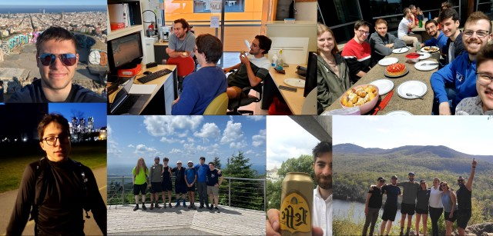
The Polystable research lab values collaboration, respect, openness, teamwork and continuous improvement. We believe that considering a wide range of ideas and viewpoints, as well as creating an environment where everyone feels valued and able to fully participate, leads to more robust and innovative research outcomes.
The Polystable research lab is integrated into the larger Laboratory for Multiscale Mechanics (LM²) that hosts many equipment and facilities related to processing, manufacturing and characterization of nano, micro, and macro-systems including, but not limited to, several commercial and industrial 3D printers, advanced custom-built additive manufacturing platforms (i.e., 6-axis robot-assisted printing, multi-material multi-process printing), dispensing robots, mixing equipment (e.g., micro-extruder), optical microscopes, and several tensile machines.
The LM² team currently consists of approximately 50 permanent members (PhD and master’s students, technicians, research associates, postdoctoral fellows and professors) from different backgrounds and nationalities, as well as many international interns (e.g., China, India, Ireland).
The Polystable and LM² labs offer an inclusive and safe space as well as learning and development opportunities for all our HQP. We encourage a healthy work/life balance for our research team (e.g., no mandatory activities and no meetings during evenings or weekends to respect HQP with family responsibilities). All trainees are treated with fairness and equity. We communicate all conference, bursary, and teaching assistantship opportunities with the whole team.

ABOUT POLYTECHNIQUE MONTREAL
Polytechnique Montréal is an internationally renowned engineering university. Located in the heart of Montréal on Mount Royal, it is renowned for the high quality of the training offered at all levels, and for its multidisciplinary and multisectoral research. It welcomes more than 10,000 students and relies on the expertise of nearly 1,600 staff members with diverse skills, including more than 300 professors.
Polytechnique is known for its innovative approach and its active role in technological, economic, and social development. Having received the Parity Certification from Women in Governance, it offers excellent working conditions, focusing on work-life balance and the well-being of its community.
The bilingual (French, English) city of Montreal is often considered one of the best cities to live for students. It is a diverse and multicultural city and a vibrant cultural hub with a thriving arts, culinary and music scene, as well as a wide array of entertainment options. It hosts numerous festivals throughout the year, such as the Montreal International Jazz Festival and Just for Laughs comedy festival. The city offers a high quality of life. Its extensive network of parks, bike paths, and green spaces make it an attractive place to live.
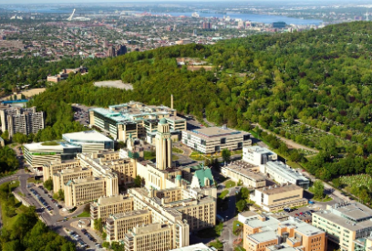
Polytechnique Montréal Saint-Lawrence River The Village Festivalgoers

